**Player Double-jump tutorial:**

This tutorial is to add a double jump mechanic to a 2D character using unity.

**Step 1: preparing tags**

In unity, just under the inspector, there will be a field named “untagged” clicking on this will make a dropdown menu appear, from here click add tag, then the plus icon, then type the name of your tag, in this case we want 2 tags, “Player” and “Ground”.

Once this is done, take the tags and apply them to their respective game objects, this is useful as it lets you easily reference game objects, or a category of objects in a script.

**Step 2: adding the code**

Once you’ve tagged the objects, open the player movement script from before, and add this at the bottom.

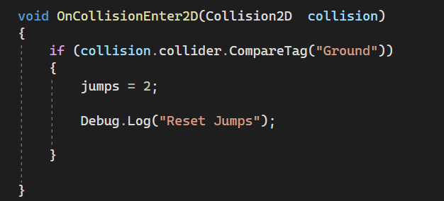

We will use an “OncollisionEnter2D” triggering method which gets triggered when a game object the script is attached to, in this case the player, collides with something.

The if statement checks if the collider that the player collided with is tagged with the tag “Ground”. If it has, it will set the jumps to 2, thereby allowing the player to jump twice.

When the player touches the ground, a debug log shows this as “Reset Jumps”.

Save the code and test the new mechanic.

Additionally, you can add more platforms to your scene by pressing ctrl+d (duplicate) on the platform and scaling it in the inspector, make sure when you do this, to make another duplicate of the platform you want, so that one is the physical object and the other acts as a jump resetter, it should look something like this.

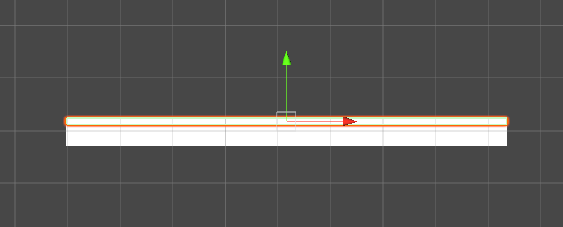

The thinner platform on top should be the only one tagged as “Ground” to prevent the underside and sides of the platforms from resetting the jump counter.